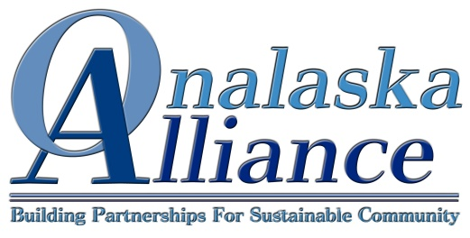
A Non-Profit Dedicated to Community Building (501c3) Membership Renewable Annually
Membership
Individuals: $60 to $600
Individuals, or households, join anywhere from $60 to $600 depending on how much they feel is appropriate for their family.

Business: $240 to $1000
Businesses, or individuals, who join for at least $240, receive a plaque.

Payment: checks, with this form, can be mailed to: Onalaska Alliance
P.O. Box 634
Onalaska, WA 98570
Contact Information
Name _____________________________________ e-mail ____________________________________
Business Name (If Applicable)_____________________________________________________________
Address _______________________________City ________________State _____ Zip _____________
Phone ___________________________________ Cell _______________________________________
Credit Card Information
Name on Card (If different that above) ____________________________________________ Back No.________
Credit Card Number ___________________________________________________________ Visa Master Card
Exp. Date __________________Signature___________________________________Today’s Date____________
Please spread my card payments over equal payments January through October, 2017: Yes No
I want to make my membership Anonymous: Yes No
------------------------------------Cut Line-----------------------------------Save for your records-------------------------------------------------
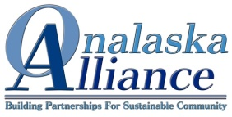
Charitable Donation Receipt: Onalaska Alliance is a 501c3, EIN 26-4577681
Your Name_________________________________________________________________
Date_____________________________ Donated Amount $_________________________
Thank you for helping to make Onalaska a great place to live, work and Play!
Donor acknowledges no receipt of material benefit in exchange for donations. This is the only receipt you will receive for this donation.

