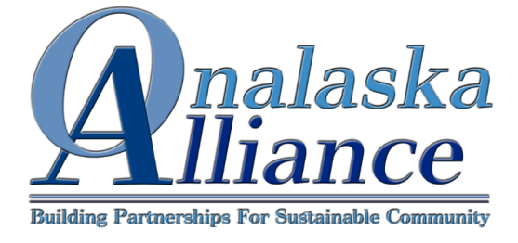
The Onalaska Alliance is annually awarding up to a $600 dollar scholarship for continuing education to an Onalaska resident, past or present, who demonstrates commitment to the Onalaska community. Scholarship applications are due by November 1st.
The Onalaska Alliance is a 501(c)3 non-profit organization whose mission and purpose is to develop innovative and sustainable economic, educational and social opportunities compatible with a rural lifestyle in Onalaska and the surrounding area, uniting people of diverse backgrounds to reduce poverty, to enhance and develop cultural and natural resource, to develop alliances with surrounding communities, and to promote the common goals of community and celebration.
Applicant Information
Name_______________________________________________
Street Address_________________________________________
Mailing Address________________________________________
City________________________ State__________ Zip Code____________________
Cell Phone ____________________________________________
Home Phone __________________________________________
E-Mail Address __________________________________________
Essay Questions Please submit essay questions on a separate piece of paper with the following; name of applicant and essay question.
- Describe your commitment to the Onalaska Community and provide example(s).
- Explain your continuing educational endeavors and how you plan to utilize your educational experience in the future.

Application Submission
Submit application and essay questions to:
Onalaska Alliance
PO Box 634
Onalaska, WA 98570

